WEEK – 1

Module -1 ServiceNow Platform and Development Fundamentals

1. What is ServiceNow:

* ServiceNow was developed by Fred Luddy to address the frustrations in IT departments, allowing business users to solve their own technical issues without relying on traditional IT support.
* ServiceNow operates on the NOW Platform, a cloud-based Application Platform as a Service (APaaS) designed for IT needs, accessible via PCs and mobile devices.
* The platform offers a wide range of pre-built applications categorized into IT, Employee, Customer, and Creator Workflows, with flexibility for users to develop their own solutions.

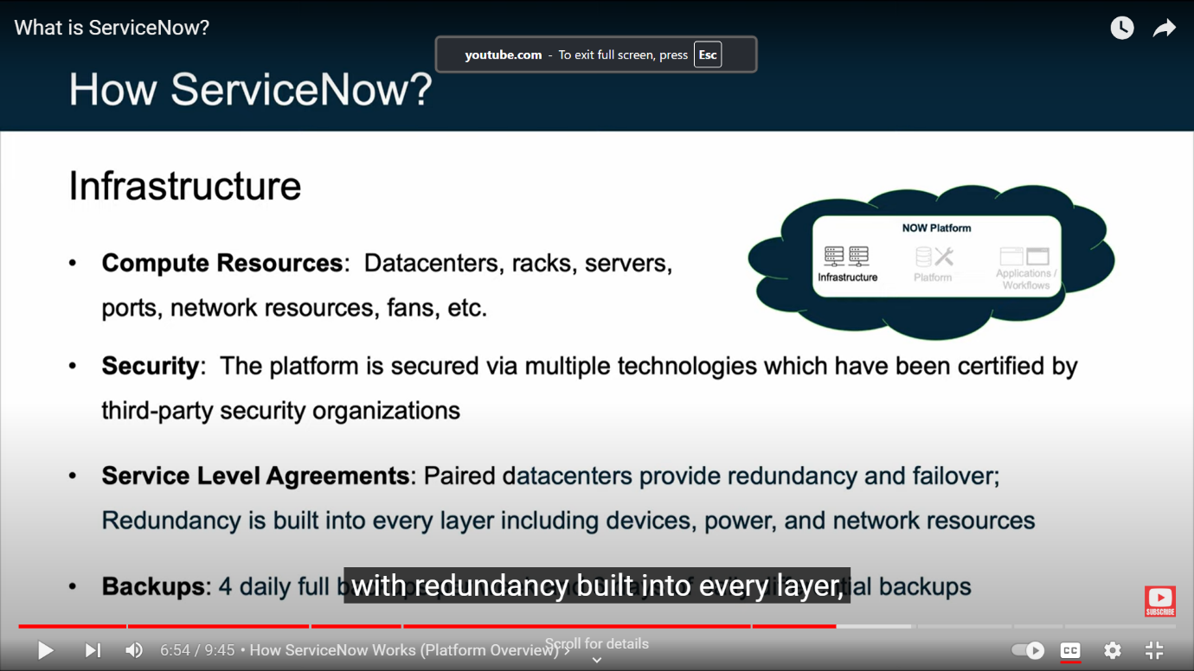

1. ServiceNow Platform Overview

* ServiceNow platform operates as an Application Platform as a Service (aPaaS), integrating infrastructure, development tools, and applications, allowing businesses to streamline processes effectively.
* ServiceNow’s robust suite of applications is organized into functional workflows, enabling organizations to address various business processes systematically and effectively.
* Role-based access is essential for security, utilizing users, groups, and roles to manage permissions efficiently and ensure that sensitive information is only accessible to authorized personnel.
* Authentication and security measures are comprehensive, supporting multiple methods and ensuring that user access is controlled and secure.

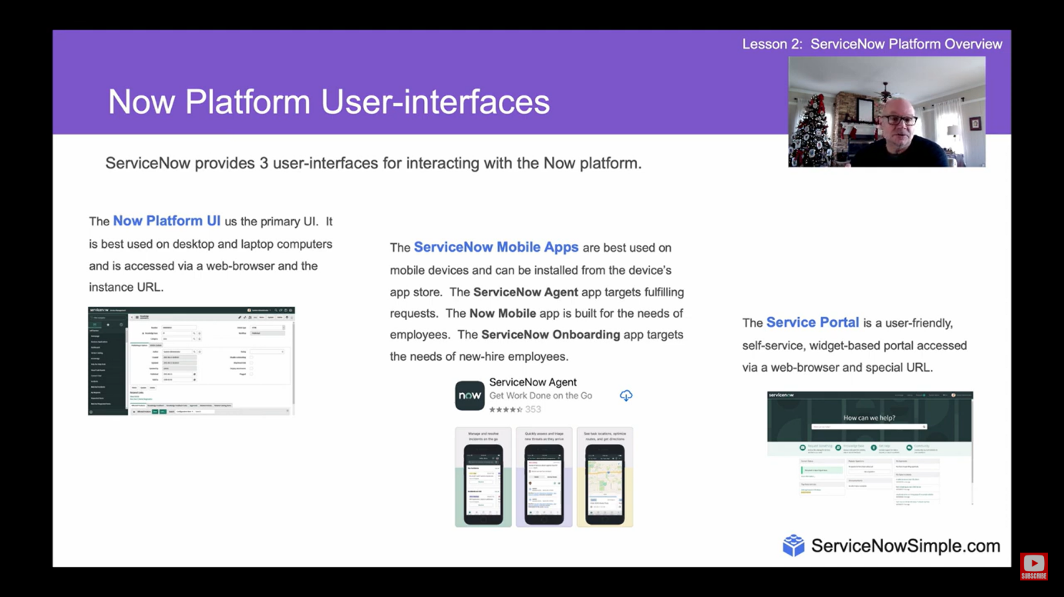

1. ServiceNow User Interface Overview

* ServiceNow UI is designed to enhance user experience, providing easy access to tools and resources tailored to their needs. This design philosophy promotes efficiency in navigating the platform.
* Key elements include the banner frame, application navigator, and content frame.
* Global Search: Allows users to find records across the entire instance quickly.
* Connect Chat: Facilitates real-time communication with other users within the platform.
* System Settings: Users can customize their UI preferences, impacting only their view.
* Favorites & History: Users can save frequently accessed items and view their recent activity.
* Application Navigator: Main tool for navigating through applications and modules, with filtering options.

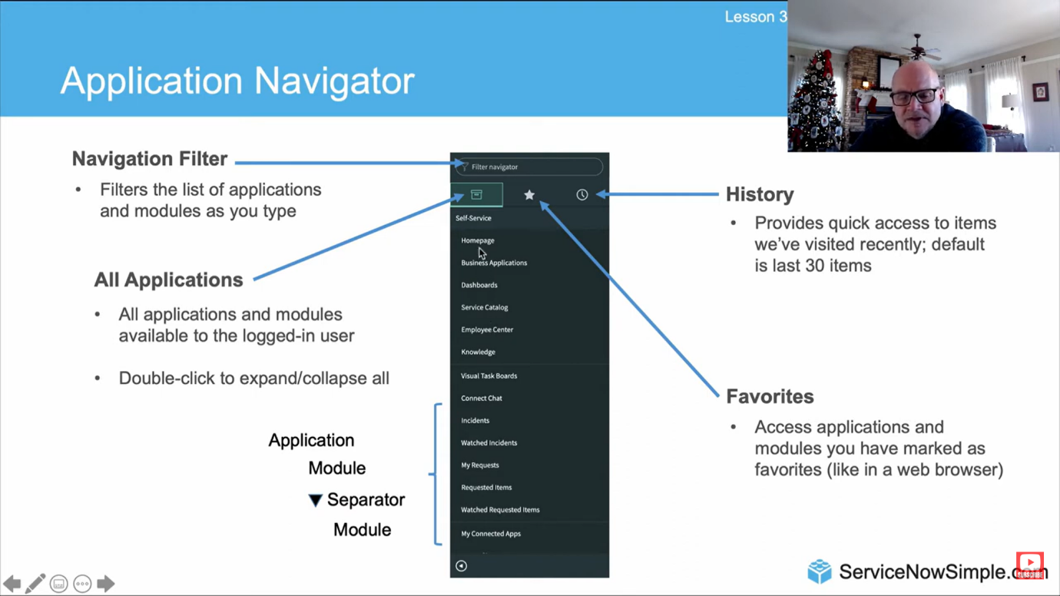

1. ServiceNow Branding Overview

* Customizing the ServiceNow interface enhances user familiarity and promotes a sense of belonging to the corporate identity.
* These intuitive Guided Setup Wizard tools streamline the branding process, making it accessible for administrators without extensive technical knowledge.
* By reflecting the company’s brand, users may feel more inclined to adopt and utilize ServiceNow effectively.

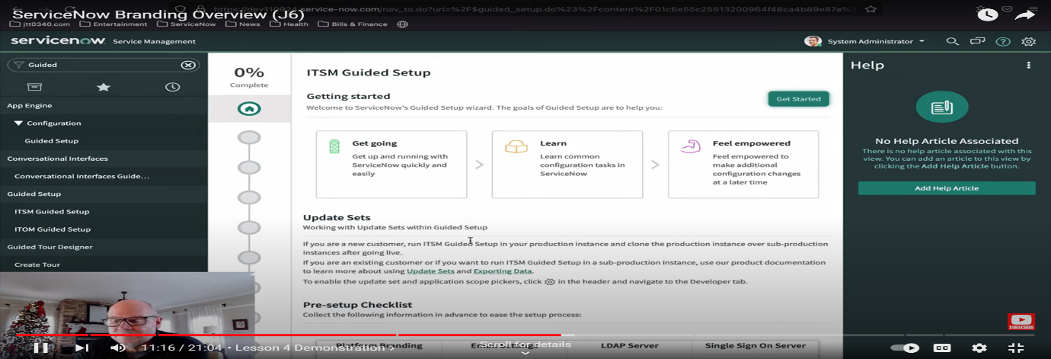

1. ServiceNow Lists and Filters

* Lists: ServiceNow’s list view is user-friendly, designed to manage large datasets effectively. It includes essential tools for sorting and filtering, which are crucial for data analysis.
* Filters: Creating saved views and filters allows users to tailor their experience, making it easier to revisit frequently accessed data sets without reconfiguring settings.
* Utilizing dot commands like table_name.list provides quick access to any table’s records, enhancing navigation efficiency within the platform.

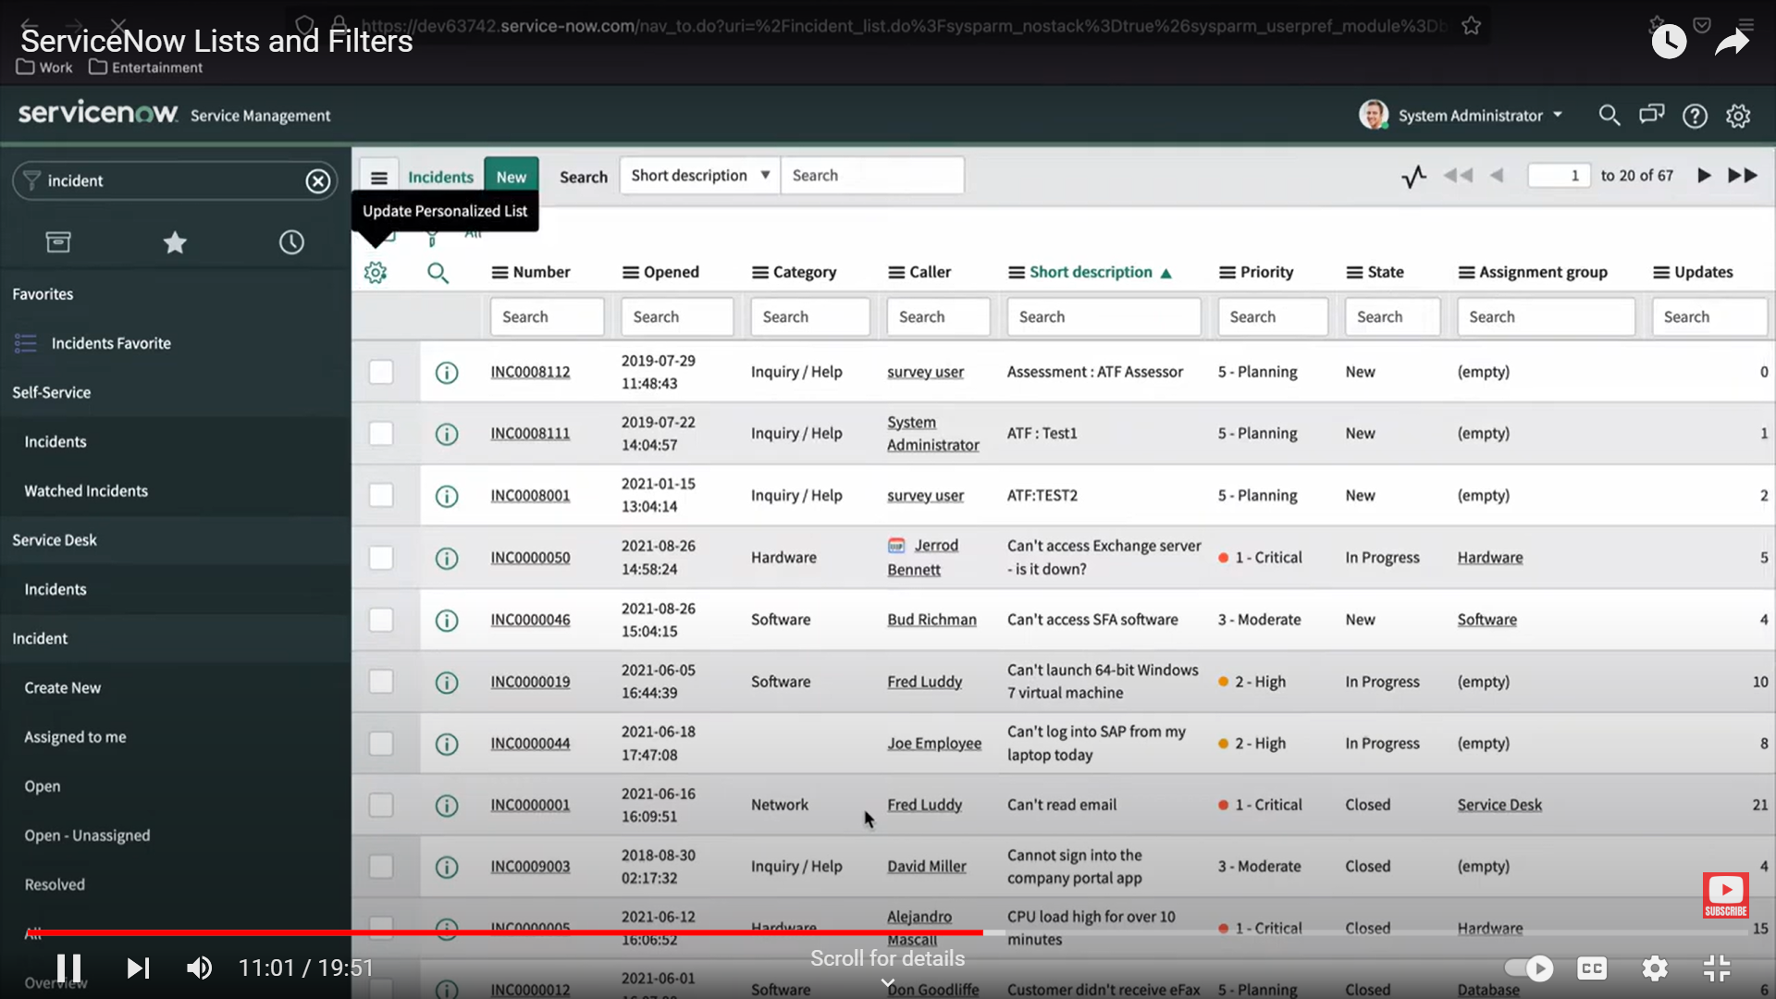

1. Forms in ServiceNow

* Forms are the primary interface for users to interact with records, making them a foundational aspect of ServiceNow’s functionality. Understanding forms is crucial for both passing certification exams and effective system usage.
* ServiceNow allows customization of form views to meet user needs, ensuring relevant information is presented based on the user’s role, thus improving usability.
* The different field types (e.g., reference, boolean) dictate how data is input and displayed, highlighting the importance of understanding data types in ServiceNow.
* Templates facilitate quicker data entry by pre-populating common fields, which is especially useful for repetitive tasks

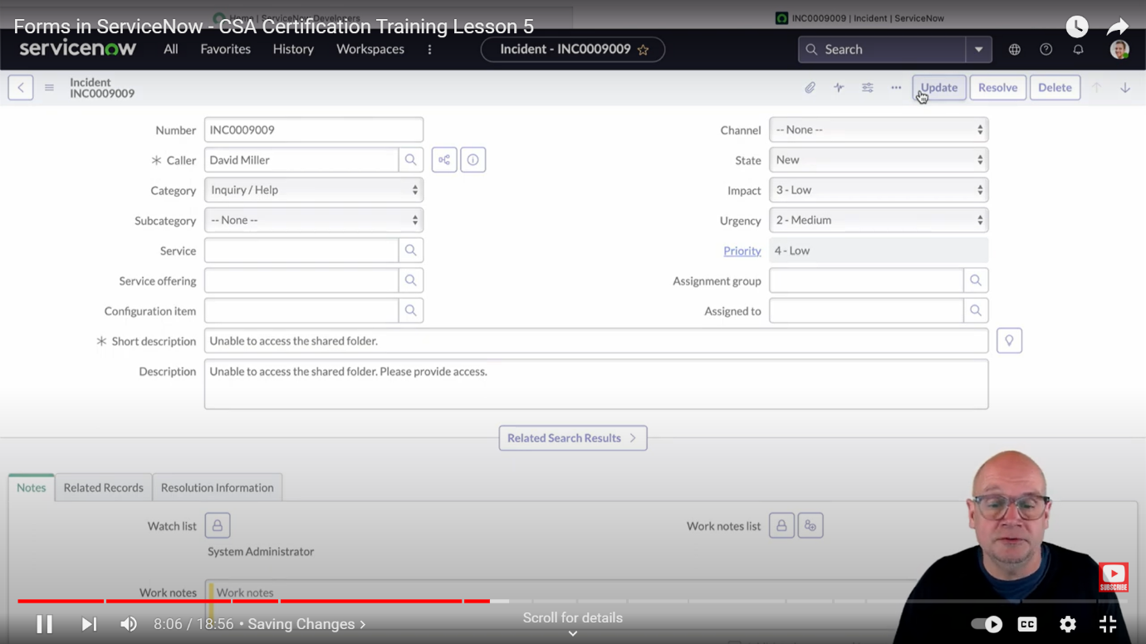

1. A Hands-on ServiceNow Tool Demo

* ServiceNow integrates various IT services into one platform, enhancing operational efficiency and service delivery.
* By assigning roles, ServiceNow ensures that users only access the information and functions relevant to their tasks, enhancing security
* Can integrate with legacy systems through the Integration Hub, facilitating smoother transitions and data management across platforms.
* The Knowledge Base feature encourages collaboration and knowledge sharing within the organization.

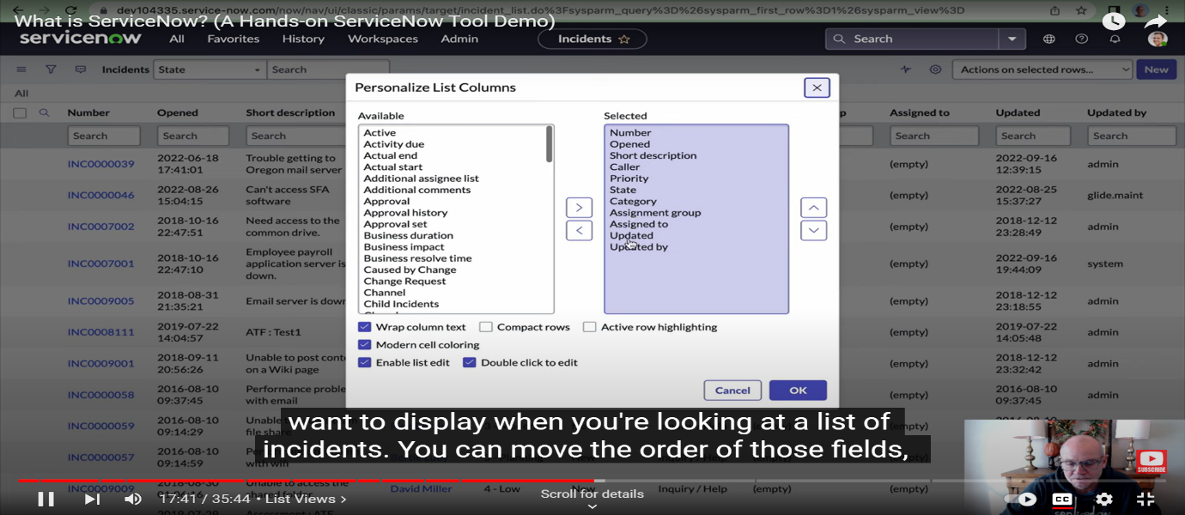

1. Introduction to Importing Data in ServiceNow

* The staging table plays a critical role by acting as a buffer between source and target data, making the import process more organized and manageable.
* ServiceNow’s automation in creating staging tables reduces manual effort
* Identifying all three data entities (source, staging, target) provides a comprehensive understanding of data flow within ServiceNow
* “staging table” and “import set table” simplifies the import process and enhances communication.

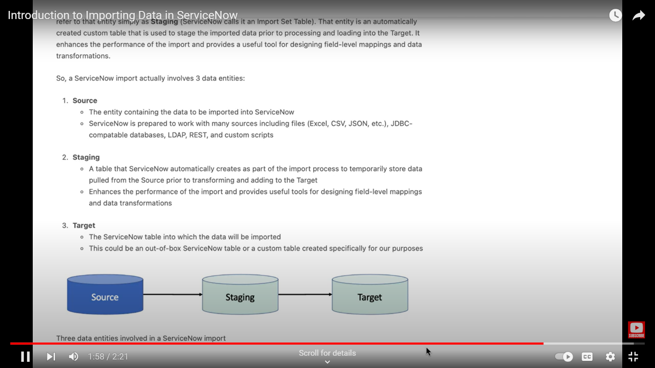

1. Creating a Data Source in ServiceNow

* Data sources in ServiceNow serve as a bridge between external data and the platform, defining how data is accessed and imported.
* The intermediary staging table allows for data validation and manipulation before final import, ensuring data integrity.
* ServiceNow supports various data sources, such as files, JDBC databases, and REST APIs, providing flexibility in data importation.
* Properly configuring parameters, including file types and database credentials, is essential for successful data retrieval and data mapping.

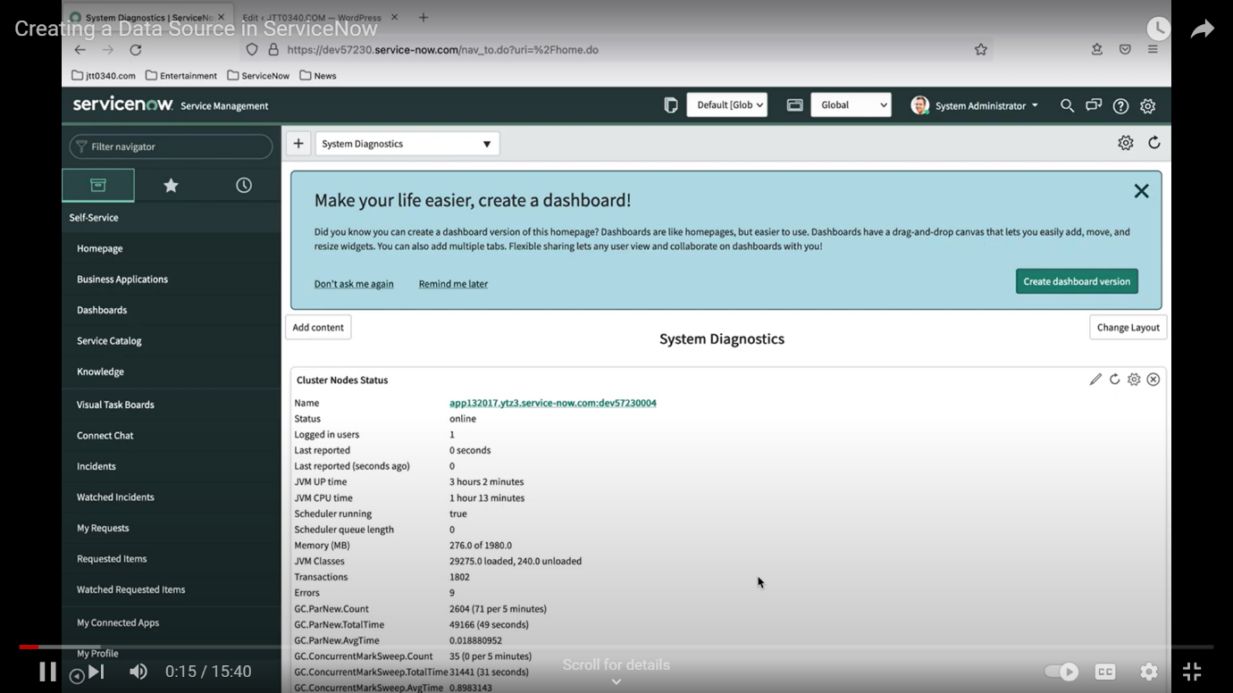

1. Understanding Import Sets in ServiceNow

* Staging tables are temporary storage areas for data being imported, allowing for validation before final data placement. This process helps maintain data integrity.
* The ability to manage records loaded into the staging table across multiple imports is vital for tracking changes and maintaining data organization.
* Each import set run is tracked through the import set table, allowing for effective management and identification of data changes over time.

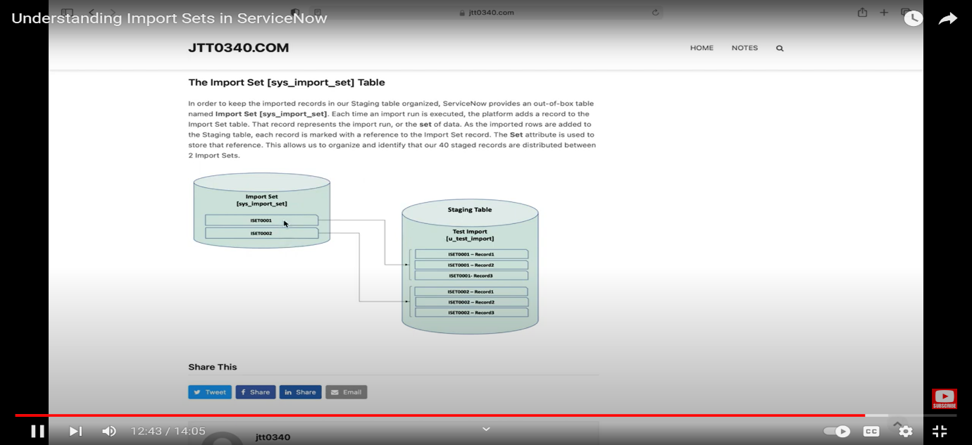

1. ServiceNow Transform Maps & Field Maps

* Creating a data source is crucial as it informs ServiceNow about the origin and structure of the data being imported.
* Each field map record ensures precise data movement, highlighting the significance of field-by-field mapping for data integrity.
* Transform maps consolidate field maps, making it easier to manage and apply complex data imports.
* Utilizing coalesce fields is essential for identifying unique records, preventing duplication in the target table.
* Testing can be done on the entire import process and scheduling recurring imports can greatly enhance data management efficiency.

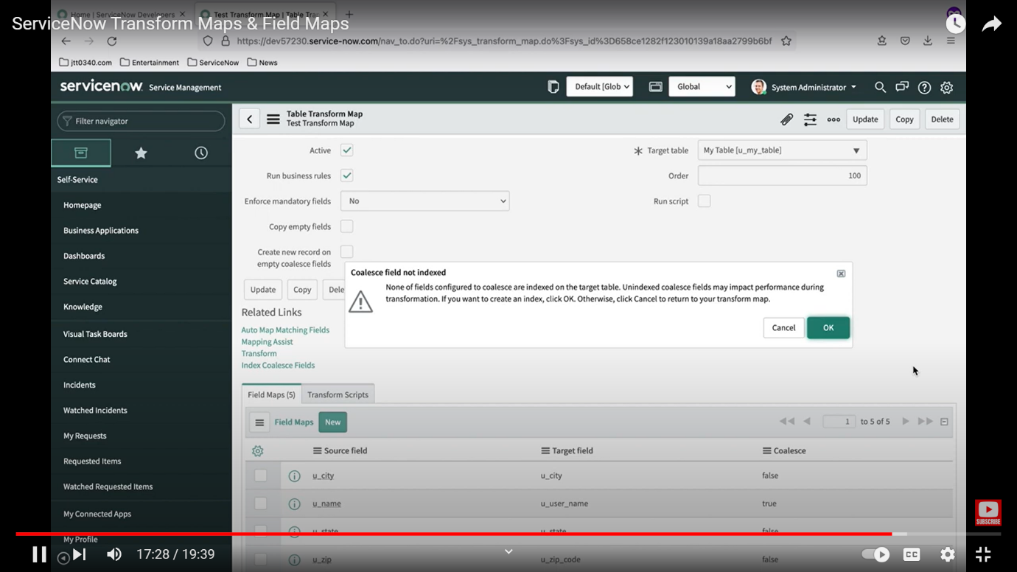

1. ServiceNow Incident Management Tutorial and Task Administration

* A task is not just a record but a structured method of managing work effectively, allowing for better organization and tracking.
* The extension of the task table for different task types ensures that common attributes are maintained while allowing for specific needs.
* Features like SLAs and inactivity monitors ensure that tasks are completed on time.
* Visual task boards offer a dynamic way to manage tasks, helping users quickly identify workload distribution

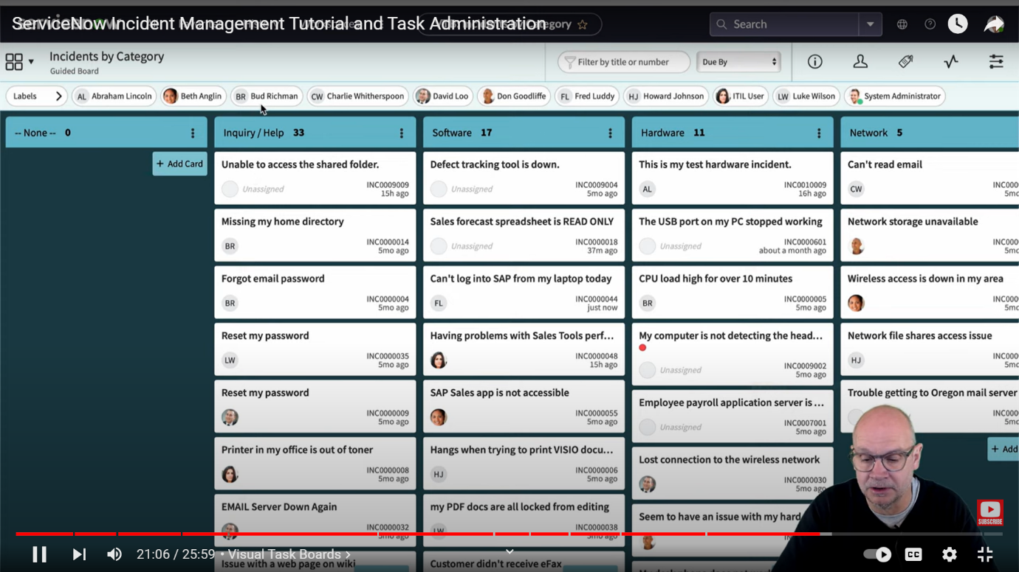

1. ServiceNow Reporting Tutorial

* Highlights three methods for creating reports, allowing flexibility in how users can access and generate reports based on their preferences.
* The ability to schedule reports for automatic email delivery ensures that stakeholders receive timely information without manual intervention.
* Sharing reports with users and groups promotes collaboration.
* ServiceNow offers over 23 report types, enabling users to choose the best visualization for their data.
* Adding reports to dashboards consolidates data visualization and improved decision making.

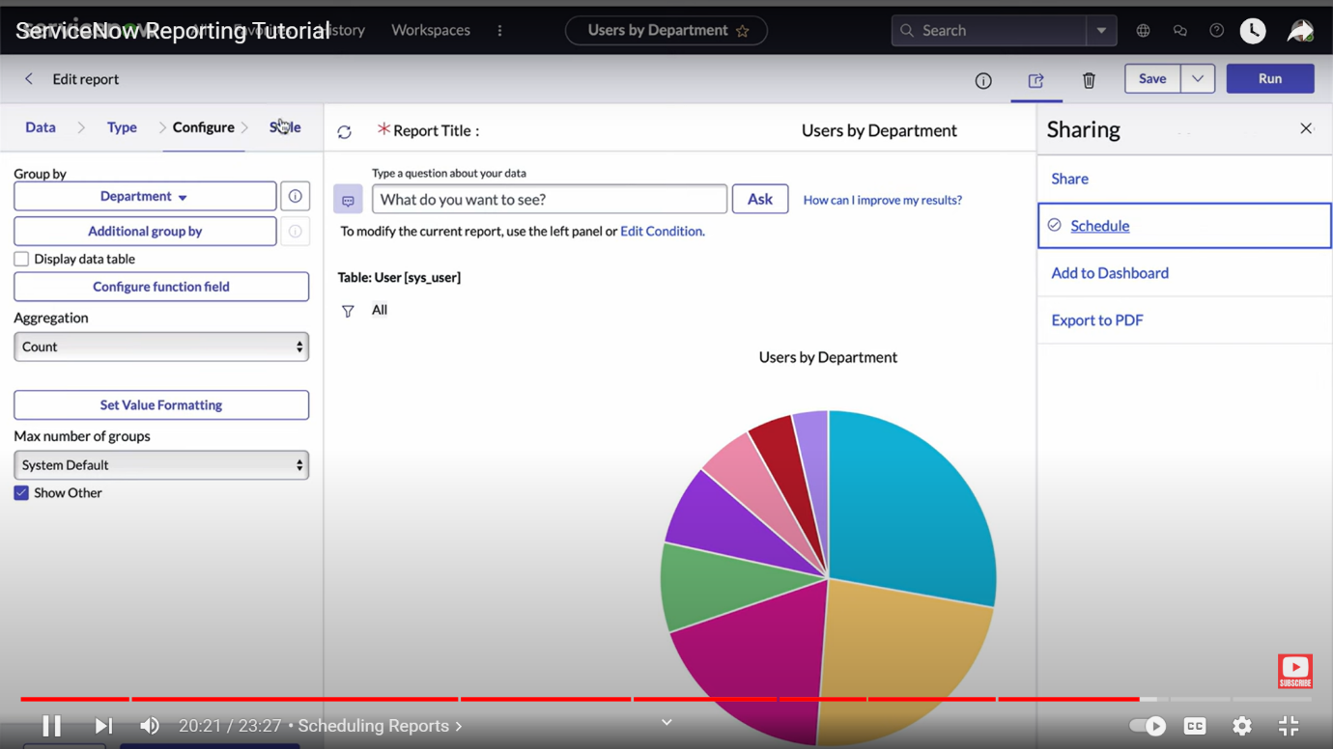

1. What is Low Code No Code Development?

* Low code no code allows non-technical users to create solutions, fostering innovation and reducing dependency on IT.
* Low code no code promotes real-time feedback and collaboration.
* While low code no code tools simplify tasks, they also abstract underlying complexity, which can lead to challenges in customization and flexibility for unique business needs.
* Low code no code does not eliminate IT roles but shifts their focus.
* Developers must adapt to support and enhance the capabilities of business users effectively.
* IT professionals must embrace a supportive role, focusing on enabling business users rather than merely fulfilling requests, which can lead to more impactful solutions.

